
ECT- Face Recognition
development specification

Item 1: Summary of Fast Face Detection Technology
Face recognition detection is of great significance. It can be applied to identity authentication and security protection, media and entertainment, image search, security payment and block data link center (cloud computing, large data analysis, on-line data) to build an intelligent computing and analysis system. In recent years, various fields have applied to intelligent analysis and analysis. Demand is increasing, and different scenarios require different applications to land. The application of chain has a clear landing goal, which is designed for public welfare, security, construction and so on.

Face recognition detection, whose function is to match the structure of face data, can quickly read the corresponding links in the picture and identify the identity. To apply landing, face recognition is not the first step. The number, security and number of pedestrians in the entrance detection, video surveillance and detection scene are not the first step. Data acquisition and intelligent analysis also play an important role. In order to build a fully automated system for analyzing the information contained in face images, more efficient face detection algorithms are needed.

We mention four aspects of the application of face recognition technology:
(1) Identity authentication and security protection. Nowadays, more and more financial institutions, office buildings, sports venues and even important facilities need to carry out identity-based access control management for a large number of personnel. Mobile phones, notebook computers and other personal electronic products are often used in the boot and use of authentication functions.

(2) Media and entertainment. Many of people's recreational activities are related to their faces. One of the most famous entertainment programs is the face change of Sichuan Opera. In the network virtual world, a large number of entertainment programs and effects can be produced through the change of face. Face-based entertainment is becoming more and more abundant in mobile phones, digital cameras and other consumer electronic products. QQ, MSN and other instant messaging tools as well as virtual avatar online games are also the broad market of face synthesis technology.

(3) Image search. At present, Google's image search is actually text search. Search engine based on face image recognition technology will have broad application prospects.

(4) Safe Payment: Mobile phone security payment and credit card consumption registration have gradually been replaced by face recognition in recent years. Consumers of various kinds, including VISA credit card users, will be prompted to carry out face scanning for registration when confirming the card.

Face recognition technology of ECT (SuperEdge) will play an important role in intelligent security. It will scan, judge, track, alarm and locate with large data analysis, intelligent AI and edge cloud computing. Block chain data will be kept anonymously.

The problems we need to solve are:
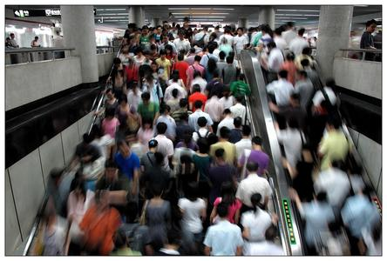
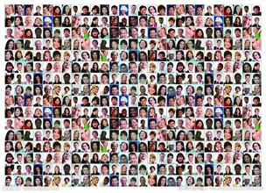
Q: Faced with the crowd, how can we quickly identify the people we welcome / don't welcome?
A: Face recognition technology is based on human facial features. For the input face image or video stream, the first step is to determine whether there is a face or not. If there is a face, the location, size of each face and the location information of each major facial organ are given. According to these information, we further extract the identity features contained in each face, and compare them with known faces, so as to recognize the identity of each face.
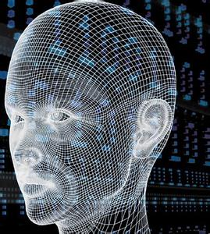

I. Source Code Reference for Face Recognition Programs：
（1）Face and Non-Face Region Segmentation Program
function result = skin(Y,Cb,Cr)
%SKIN Summary of this function goes here
% Detailed explanation goes here
a=25.39;
b=14.03;
ecx=1.60;
ecy=2.41;
sita=2.53;
cx=109.38;
cy=152.02;
xishu=[cos(sita) sin(sita);-sin(sita) cos(sita)];
% If the brightness is greater than 230, the long and short axes will be enlarged to 1.1 times if (Y > 230)
a=1.1*a;
b=1.1*b;
end
% Calculate according to the formulaCb=double(Cb);
Cr=double(Cr);
t=[(Cb-cx);(Cr-cy)];
temp=xishu*t;
value=(temp(1)-ecx)^2/a^2+(temp(2)-ecy)^2/b^2;
% If it is more than 1, it is not skin color, returning 0; otherwise, it is skin color, returning 1 if value > 1.
result=0;
else
result=1;
end
end

（2）Face Recognition Procedure
function eye = findeye(bImage,x,y,w,h)
%FINDEYE Summary of this function goes here% Detailed explanation goes here
part=zeros(h,w);
% two value
for i=y:(y+h)
for j=x:(x+w)
if bImage(i,j)==0
part(i-y+1,j-x+1)=255;
else
part(i-y+1,j-x+1)=0;
end
end
end
[L,num]=bwlabel(part,8);
% If there are more than two rectangles in the area, it is considered that there are eyes if num < 2
eye=0;
else
eye=1;
end
end

(3) Main Program for Face Recognition
clear all;
% Read in the original image
I=imread('face3.jpg');
gray=rgb2gray(I);
ycbcr=rgb2ycbcr(I);
% Convert the image into YCbCr space heighth = size (gray, 1);% read image size
width=size(gray,2);
for i=1:heighth
% Binary Image Using Skin Color Model
for j=1:width
Y=ycbcr(i,j,1);
Cb=ycbcr(i,j,2);
Cr=ycbcr(i,j,3);
if (Y<80)
gray(i,j)=0;
else
if (skin(Y,Cb,Cr)==1) % Image binarization based on color model
gray(i,j)=255;
else
gray(i,j)=0;
end
end
end
end
se=strel('arbitrary',eye(5)); % Morphological Processing of Binary Image
gray=imopen(gray,se);
figure;imshow(gray)
[L,num]=bwlabel(gray,8); % Selection of White Areas in Graphs by Marking Method stats=regionprops(L,'BoundingBox'); % Measuring regional attributes
n=1; % Store all rectangular blocks filtered
result=zeros(n,4);
figure,imshow(I);
hold on;
for i=1:num % Start screening for specific regions
box=stats(i).BoundingBox;
x=box(1); % Rectangular coordinates X
y=box(2); % Rectangular coordinates Y
w=box(3);% Rectangle width w
h=box(4);% Rectangle height h
ratio=h/w;% Ratio of width to height
ux=uint16(x);
uy=uint8(y);
if ux>1
ux=ux-1;
end
if uy>1
uy=uy-1;
end
if w<20 || h<20|| w*h<400 % The range of length and width of rectangle and the area of rectangle can be set to continue by oneself.
elseif ratio<2 && ratio>0.6 && findeye(gray,ux,uy,w,h)==1
% According to the "three chambers and five eyes" rule, the ratio of height to width should be within (0.6,2);
result(n,:)=[ux uy w h];
n=n+1;
end
end
if size(result,1)==1 && result(1,1)>0% Marking areas that may be human faces
rectangle('Position',[result(1,1),result(1,2),result(1,3),result(1,4)],'EdgeColor','r'); else
% If the rectangular area satisfying the criteria is larger than 1, then it is filtered according to other information.
a=0;
arr1=[];arr2=[];
for m=1:size(result,1)
m1=result(m,1);
m2=result(m,2);
m3=result(m,3);
m4=result(m,4);
% Get data that matches faces
if m1+m3<width && m2+m4<heighth && m3<0.2*width
a=a+1;
arr1(a)=m3;arr2(a)=m4;
%rectangle('Position',[m1,m2,m3,m4],'EdgeColor','r'); end
end
% The Minimum Region of Face Length and Width
arr3=[];arr3=sort(arr1,'ascend');
arr4=[];arr4=sort(arr2,'ascend');
% Calibration of the final face area based on the obtained data\
for m=1:size(result,1)
m1=result(m,1);
m2=result(m,2);
m3=result(m,3);
m4=result(m,4);
% Final face calibration
if m1+m3<width && m2+m4<heighth && m3<0.2*width
m3=arr3(1);
m4=arr4(1);
rectangle('Position',[m1,m2,m3,m4],'EdgeColor','r');
end
end
end

2. Explanation of ECT Face Recognition Detection Program Usual face recognition programs mainly include transforming image into YCbCr color space, analyzing and processing image morphology, calculating the value information of the image, and then judging.ECT face scanning is more intelligent. It carries out behavior tracking, information locking and intelligence on standard face scanning. Analysis.
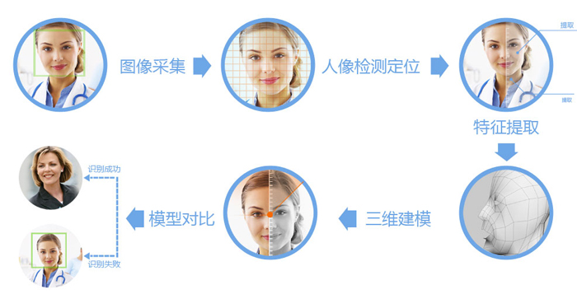

ECT Face Recognition Technology Innovation Solution:
1. Visible light
Different light environment is a major factor affecting the accuracy of face recognition.
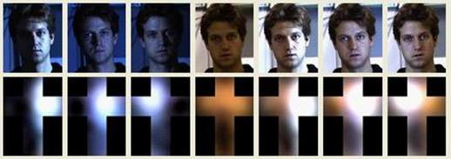

2. Attitude
Most face recognition algorithms have only 15 degrees of face pose-change.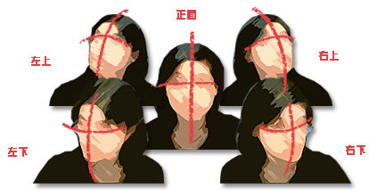

3. Shielding
Hats, glasses, scarves, hairstyles and other factors may block the face.
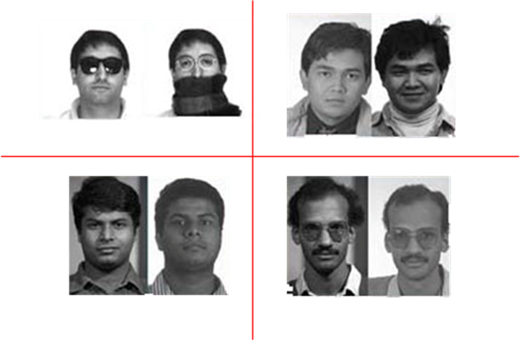

4. Age
Face recognition for photos of the same person at different ages is also a technical challenge.
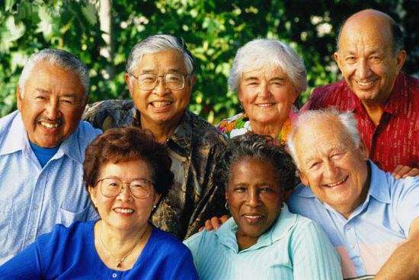

5. Massive Face Database
When the scale of face block chain database reaches more than 1 million, the recognition accuracy of face recognition algorithm will be a great test, and the larger the scale of face database, the greater the test.
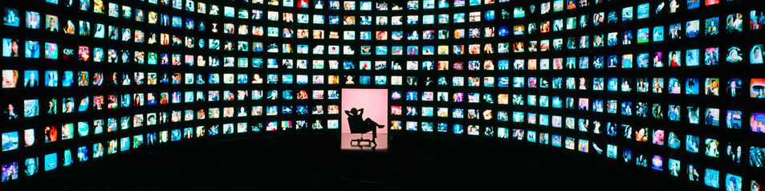

Combining the above five points with our later technical projects, we will further upgrade and optimize the face AI intelligent recognition system, and bring new alternative solutions and products to the market.

